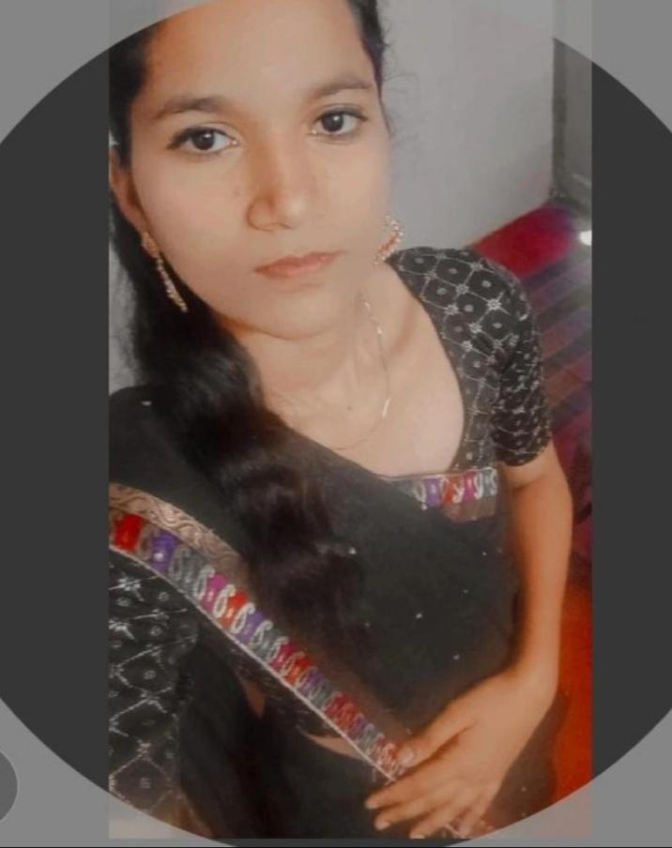**I FRESHER  
I'M pooja. V**

[poojavvijayakumar2004@gmail.com](mailto:poojavvijayakumar2004@gmail.com)

730562580

**Date of Birth 29/12/2003**

**Gender female**

**Nationality Indian**

**Marital Status Single**

**Languages Known Tamil, English, Malayalam**

# **SUMMARY**

Fresher with a degree in from Government Arts and Science College Gudalur, flexible, motivated

organized individual with leadership qualities seeking Opportunity to grow consistently

with commitment and dedication towards my work and company.

# **HOBBIES**

Singing .. book reading.. song

# **Education**

Bsc.Computer science

Government Arts and Science

College Gudalur , Bharathiar University

# **SKILLS**

C

C++

# **DECLARATION**

I here by declare that the above mentioned upto my knowledge